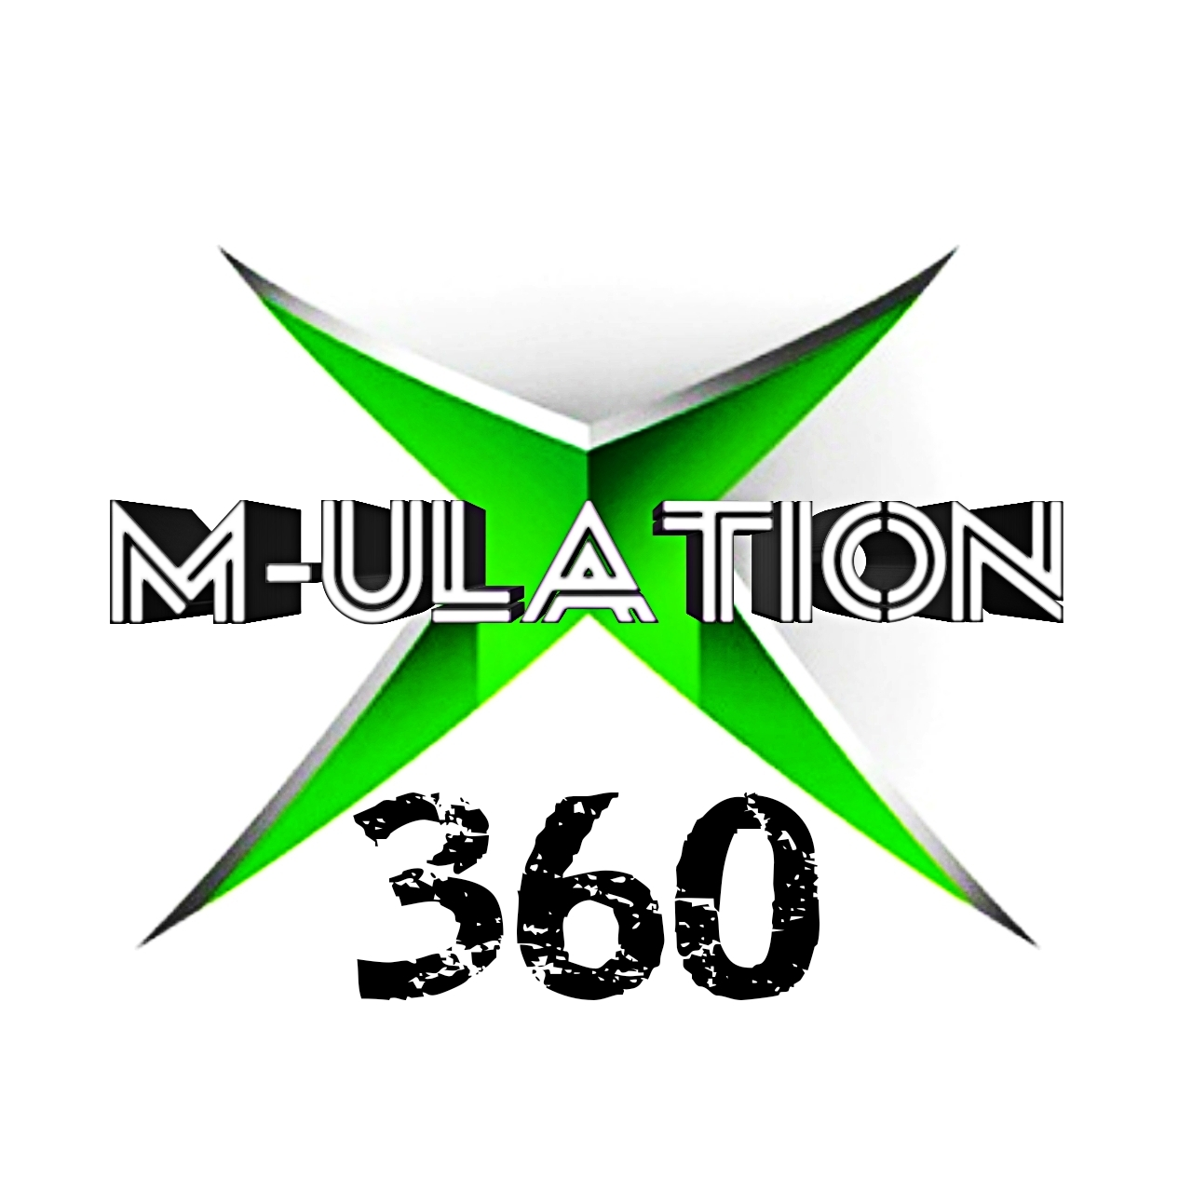
XM-ULATION & RETRO GAMING

Thank you for your recent purchase of an XM-ULATION X360 2TB – 6TB versions. This is our RGH modded version of the Microsoft XBox 360. RGH stands for Reset Glitch Hack and it’s relies on a mod chip to be able to do the hack.
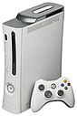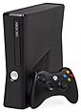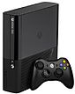
Left: Original model Xbox 360 Premium (2005)
Centre: Redesigned slim model Xbox 360 S (2010)
Right: Latest model Xbox 360 E (2013)

The Xbox 360 is a home video game console developed by Microsoft. As the successor to the original Xbox, it is the second console in the Xbox series. It competed with Sony's PlayStation 3 and Nintendo's Wii as part of the seventh generation of video game consoles. It was officially unveiled on MTV on May 12, 2005, with detailed launch and game information announced later that month at the 2005 Electronic Entertainment Expo.

The Xbox 360 is a home video game console developed by Microsoft. As the successor to the original Xbox, it is the second console in the Xbox series. It competed with Sony's PlayStation 3 and Nintendo's Wii as part of the seventh generation of video game consoles. It was officially unveiled on MTV on May 12, 2005, with detailed launch and game information announced later that month at the 2005 Electronic Entertainment Expo.
For our purpose, we are using all the 360 models apart from the first ones, which did not have HDMI outputs. We are also adding some of the greatest games in history to these – so you can relive incredible gaming adventures like GTA V, Injustice Gods Amongst Us, Halo 4, Star Wars – The Force Unleashed 2 and Dead Space 3.
The following is some brief information on how to use the X360. In reality though, we could probably write a book about it – there are so many options and extras you can do with an RGH 360. We advise you only to explore this if you are tech-minded, it is easy to brick an Xbox 360 that way. Please remember the golden rules though…. Never update the dash online and never go into Xbox Live – without a Stealth Server (more on this later).

GETTING STARTED – SYNCING YOUR WIRELESS CONTROLLER

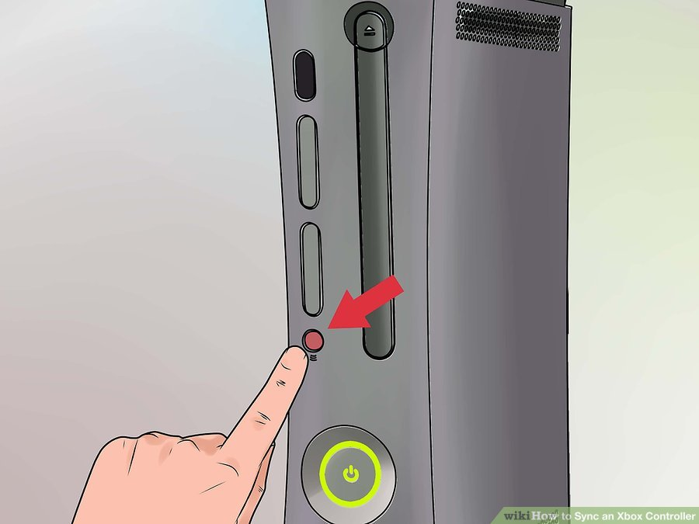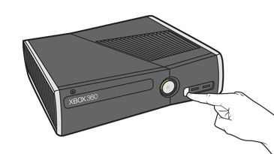

Press the Xbox 360's front-facing power button to turn the console on. Press and hold the controller's Guide button, the bulbous button with the big “X” logo located in the centre of the controller. This turns the controller on, indicated by the flashing green Ring of Light surrounding the Guide button.
Locate the connect button on the front of your Xbox 360 console. On the original model, this lies just under the disc tray. On all other models, such as the Xbox 360 S or E editions, it's on the lower right side of the console's face. Press the console's connect button. Depending on the type of 360 you have, the circular light around the console's power button will either flash or spin around the button's perimeter.
Press the connect button on the controller, located on top of the controller just above the battery compartment, within 20 seconds of pressing the corresponding button on the console. The controller's Ring of Light will glow and spin. Once the light stops spinning and glows a solid green on both console and controller, the controller has successfully synced. Repeat the process for each successive controller you wish to connect.

Tips
The Ring of Light around the controller's Guide button indicates the player order. The circular light is divided into four sections -- a light in the upper-left section indicates that the controller is set up for player one, the upper right for player two, lower right for player three, and lower left for player four.
If you experience difficulties syncing your Xbox 360 controller, first turn the console off, then turn it back on and attempt the process again.
If rebooting doesn't do the trick, ensure that the wireless controller has a fresh set of AA batteries or a fully-charged rechargeable battery pack. If you have an Xbox 360 Play and Charge Kit supplied by us, you can charge the controller via the console's USB port while playing.

AURORA 360
The settings menu in Aurora is passcode protected and is currently 0-0-0-0. You can change this to any four-digit pin that you prefer.
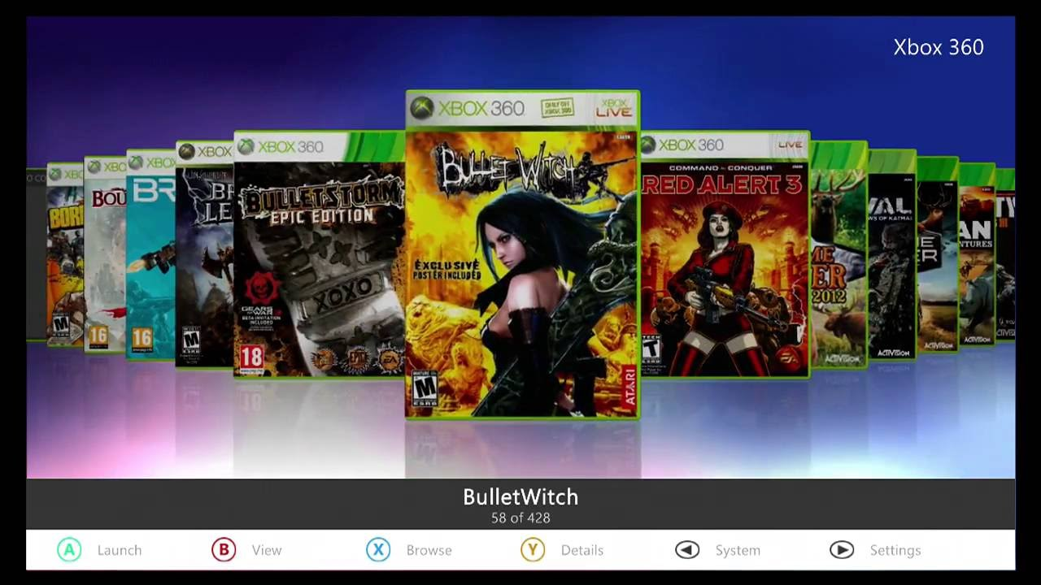

Upon booting up, your X360 should automatically go straight to the Aurora Dashboard. Don’t worry if, in the rare occasion, it goes to the old standard Xbox 360 dash. To rectify this, simply press the Xbox logo button on the centre of your controller (Guide button)– then select Aurora Home. It will boot into Aurora from there and should be fine the next time.
When all the game covers have populated, you can scroll through the various games by using Right Trigger & Left Trigger on your controller. To select the game to play, it’s as simple as pressing the Green button (A) on your controller. If you would like a bit more information on the game – press the Yellow button (Y). It will usually have a synopsis about the game, screen shots and there may even be cheats too (we have loaded hundreds of games’ cheats into it). You can see an example of this below and the various options it gives. The fifth icon in the list, for example, (the one that looks like a polaroid with a triangle on it) – it is the one you would select for screenshots and trailers.

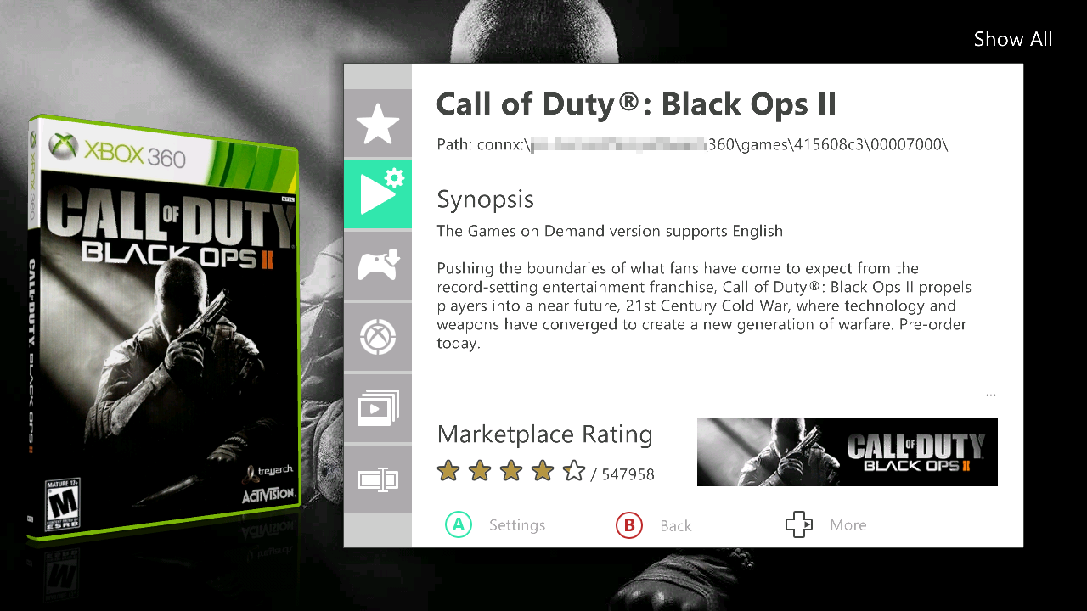

Now many games will require you to set up your own X360 profile before you begin. This will be saved on the system permanently – so just follow the steps that it asks you to, give yourself a nickname, but do not attempt to connect your account to Xbox Live (without a Stealth Server such as NINJA).
You will probably notice in the game cover list, as you are scrolling through, that there are some games that have more than one cover. These are not duplicates, they are however, multi-disc games. You can hide the multi-disc cover by select the bottom option in the list above and pressing D-PAD left or right (until the word hide appears). Be careful though, the same option allows you to delete a game. We have set the games to Auto-Swap discs during gameplay – so you don’t need to worry about that part. When you are choosing the game however, please choose the first cover in the sequence, as this represents Disc 1.

Saving game position will occur at the normal Auto-Save checkpoints, during the game. It will ask you before the game have started, which hard drive you would like to save your game progress on. There is no correct answer to this, you can save on any of the hard drives -if you have more than one. There will be adequate space on them to do this, however it might make more sense to save game progress on the internal master hdd – however its entirely your choice.

Exiting from any game at any time is done by pressing the Xbox logo button (the GUIDE button). After doing this, a menu will appear which gives you the option to return to Aurora once again.
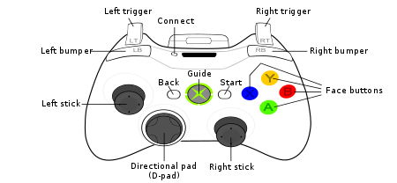

You can flick through the different gaming categories (Xbox 360, Kinect, Xbox Classic, Emulators etc), by using the Right or Left Bumper button. To select a category, press the green A button, the Face button, as it’s called on the diagram above. You can also change the default view (what populates first after booting) or if you prefer to see all the games in one list, that can be altered very easily too. Just press the red B Face button on your controller – the following menu screen will appear and you can customise your game list instantaneously.

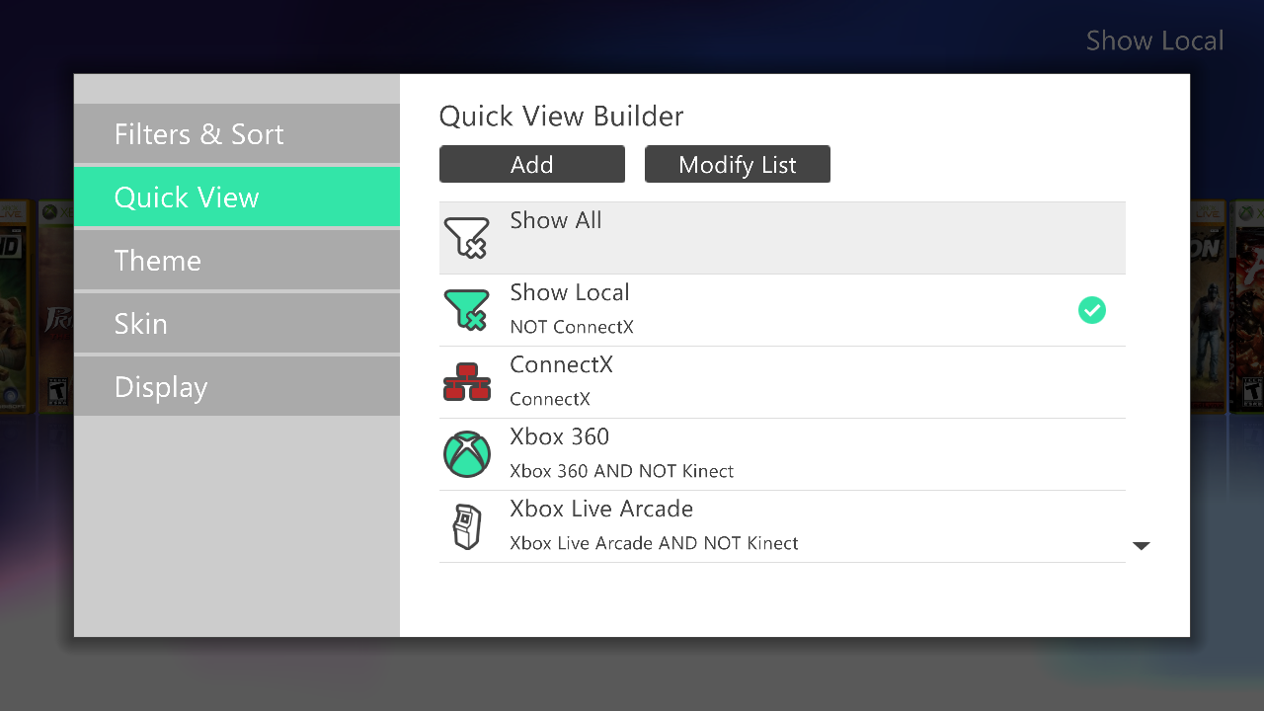

APPLICATIONS

We have included several Apps on the X360, the easiest way to access them is via File Explorer on Aurora (hit BACK button to launch it) – these are not essential to use for your gaming enjoyment. There is one that we have used quite extensively to setup the X360, it’s called DASHLAUNCH. In this app you can do things like change the fan speed, alter the way the console shuts down and block Xbox Live (we have this done already). There are other crucial file paths that have been set in this too, so please be careful if you are browsing through the many options – if you save your changes, it will overwrite ours.
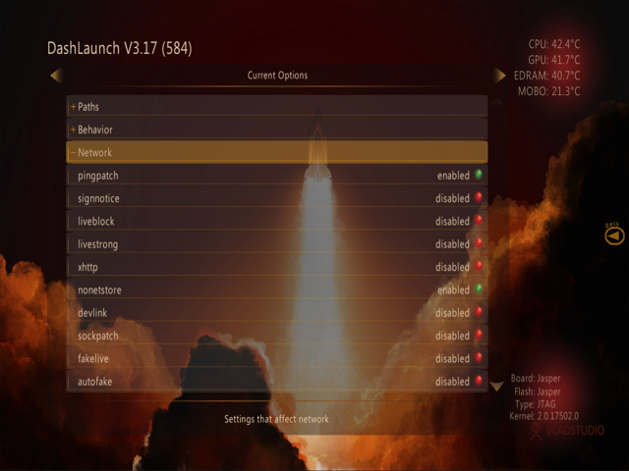

Don’t panic if you have to hard-reset your console at any time. Our modded X360, just like any modified system, can crash – although this should be rarely. Reasons for this could be due to the system overheating, so if you find this does happen regularly – please increase your fan speed to a higher setting. There is an option in Aurora that automatically enables a higher speed when needed. After the internal system has cooled to good effect, it again automatically lowers the speed.
If you do need to hard reset your X360, it will not affect the hacked files or the chip in anyway negatively.

KINECT

For your extra enjoyment, we have included a Kinect sensor. This plugs straight into the port at the back of the console (Slim version). If we have supplied a white X360, the Kinect sensor will have a power adapter with it - which will need to be plugged into the mains.

To setup your sensor, you need to go back to the standard Xbox 360 dashboard. This is achieved via the guide button on your controller. Scroll over to System Settings and select it. You will be then brought back to the old menu, where you have a section specifically setting up Kinect. After this is done, you will be able to play the games that are solely for Kinect. These can be found in Aurora, either in the Kinect section, or amongst the XBLA games.

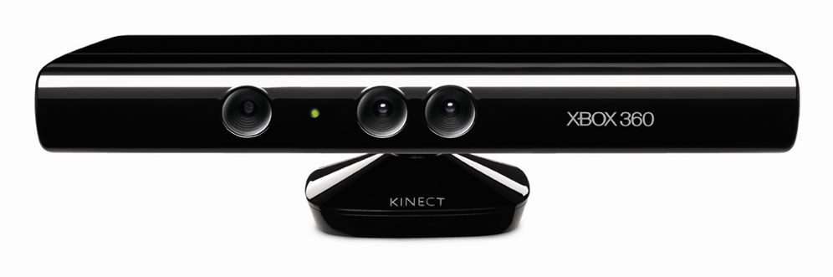

Now here’s a few tips

- Plug in the USB hdd(s) before you switch on the console. Sometimes it takes them a bit longer to be identified by the 360 if they are attached, when already powered on.
- To sync a wireless controller, hit the sync button on the front of the console (beside USB ports) and the tiny sync button on the top of the controller. It will stop flashing and after a few seconds, it should be fully in sync.
- We have installed cheats for over 500 Xbox 360 games – this is built into Aurora. To access these Trainers, highlight the game, press Y button. The top option will give you the various cheats that are available (use D-Pad left).
- If you decide to hide multi-disc covers, make sure you are hiding the right one – when it’s gone, you can’t get it back on screen.
- Don’t forget in Aurora, you can scroll through the Xbox 360 game categories such as XBLA, HOMEBREW, KINECT, XBOX 360, XBOX CLASSIC (if you have chosen these games on your system). To do this, you simply press the RB button on your controller. It takes a few seconds for the new set of game covers to populate. If for any reason they don’t, just reselect the category again using RB.

ENJOY YOUR GAMING,
XM-ULATION

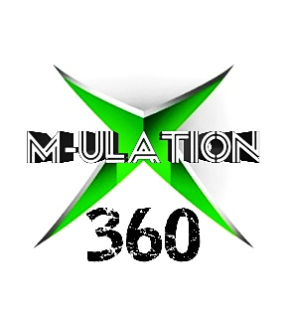
NOTES

